##### create table loan_table_1 (id int,member_id int,loan_amnt int,funded_amnt int,funded_amnt_inv int,term string,init_rate string,installment float,grade string,subgrade string, emp_title string,emp_length string,home_ownership string,annual_inc bigint,verification_status string,issue_d string,loan_status string,pymt_plan string,url string,

##### desc string,purpose string,title string,zip_code string,addr_state string,dti float,delinq_2yrs int,earliest_cr_line string,inq_last_6mths int, mths_since_last_delinq string,mths_since_last_record string,open_acc int,pub_rec int,revol_bal int,revol_util string,total_acc int,initial_list_status string,out_prncp float,out_prncp_inv double, total_pymnt float,total_pymnt_inv float,total_rec_int float,total_rec_late_fee float,recoveries float,collection_recovery_fee float,last_pymnt_d string, last_pymnt_amnt float,next_pymnt_d string,last_credit_pull_d string,collections_12_mths_ex_med float,mths_since_last_major_derog string,policy_code int, application_type string,annual_inc_joint string,dti_joint string,verification_status_joint string,acc_now_delinq int,tot_coll_amt string,tot_cur_bal string, open_acc_6m string,open_il_6m string,open_il_12m string,open_il_24m string,mths_since_rcnt_il string,total_bal_il string,il_util string, open_rv_12m string,open_rv_24m string,max_bal_bc string,all_util string,total_credit_rv string,inq_fi string,total_fi_tl string,inq_last_12m string)

##### ROW FORMAT SERDE 'org.apache.hadoop.hive.serde2.OpenCSVSerde'

##### WITH SERDEPROPERTIES

##### (

##### "separatorChar" = ",",

##### "quoteChar" = "\""

##### ) STORED AS TEXTFILE

##### tblproperties('serialization.null.format'='','skip.header.line.count'='2');

##### LOAD DATA INPATH '/user/anabig114231/LoanStats3a.csv' INTO TABLE loan_table_1;

##### LOAD DATA INPATH '/user/anabig114231/LoanStats3b.csv' INTO TABLE loan_table_1;

##### LOAD DATA INPATH '/user/anabig114231/LoanStats3c.csv' INTO TABLE loan_table_1;

##### LOAD DATA INPATH '/user/anabig114231/LoanStats3d.csv' INTO TABLE loan_table_1;

##### create table reject_table1(amount_requested string,Application_date string,loan_title string,risk_score string,Debt_To_Income string,zipcode string, state string,employment_length string,policy_code string)

##### ROW FORMAT SERDE 'org.apache.hadoop.hive.serde2.OpenCSVSerde'

##### WITH SERDEPROPERTIES

##### (

##### "separatorChar" = ",",

##### "quoteChar" = "\""

##### ) STORED AS TEXTFILE

##### tblproperties('serialization.null.format'='','skip.header.line.count'='2');

##### LOAD DATA INPATH '/user/anabig114231/RejectStatsA.csv' INTO TABLE reject_table1;

##### LOAD DATA INPATH '/user/anabig114231/RejectStatsB.csv' INTO TABLE reject_table1;

##### LOAD DATA INPATH '/user/anabig114231/RejectStatsD.csv' INTO TABLE reject_table1;

##### ## Total Loan issuance by yearly & quarterly and calculate growth rate by quarter on quarter and year on year

##### select sum(loan_amnt) as total_loan_issued,

##### substr(issue_d,5) Year

##### from loan_table_1

##### group by substr(issue_d,5) ;

##### 

##### 

##### select Year, (diff/previous)*100 Percentage_Growth from

##### (select substr(issue_d,5) Year, sum(loan_amnt) - lag(sum(loan_amnt)) over( order by substr(issue_d,5)) diff,

##### lag(sum(loan_amnt)) over(order by substr(issue_d,5)) previous from loan_table_1

##### group by substr(issue_d,5)) t1

##### order by Year;

##### create table tbl_quarter1 as SELECT id,substr(issue_d,1,3) month,loan_amnt,substr(issue_d,5) as loan_year FROM loan_table_1;

##### create table quarter_table1 as select id as id,case

##### when lower(month) in ('jan','feb','mar') then 1

##### when lower(month) in('apr','may','jun') then 2

##### when lower(month) in ('jul','aug','sep') then 3

##### when lower(month) in ('oct','nov','dec') then 4

##### else 0 end as year_quarter, loan_amnt as total_amnt,loan_year as loan_year from tbl_quarter1;

##### select year_quarter, sum(total_amnt) quarter_wise_loan

##### from quarter_table1

##### where year_quarter > 0

##### group by year_quarter;

##### 

##### select loan_year, year_quarter, (diff/previous)*100 Percentage_Growth

##### from (select loan_year , year_quarter, sum(total_amnt) - lag(sum(total_amnt))

##### over( order by loan_year,year_quarter) diff,

##### lag(sum(total_amnt)) over(order by loan_year,year_quarter) previous from quarter_table1

##### group by loan_year, year_quarter ) t2

##### where year_quarter <> 0 and not isnull((diff/previous)*100)

##### 

##### 

##### 

##### 

##### # Percentage of loans based on reported loan purpose

##### create table loanstble_1 as SELECT sum(loan_amnt) as amount_loan, purpose as purpose from loan_table_1 group by purpose;

##### create table loanstble_2 as select sum(loan_amnt) as total_loan from loan_table_1;

##### create table loanstble_3 as select loanstble_1.purpose as purpose, loanstble_1.amount_loan as loan,loanstble_2.total_loan as total_loan from loanstble_1 cross join loanstble_2;

##### select purpose as purpose, 100*(loan/total_loan) as Percent_of_total from loanstble_3;

##### 

##### 

##### Loan Issuance by state – classify the states based on loan issuance by $50+ MM, $25-50 MM, $10-25 MM and $0-10 MM

Create table state_category_1 as Select addr_state as state, sum(loan_amnt) as total_amnt From loan_table_1

Group by addr_state;

Select state as addr_state, total_amnt as total_loan, case

When total_amnt <1000000 then 'LOW'

When total_amnt <2500000 then 'MEDIUM'

When total_amnt <5000000 then 'HIGH'

When total_amnt >5000000 then 'VERY HIGH'

End As Category from state_category_1

Order by Category;

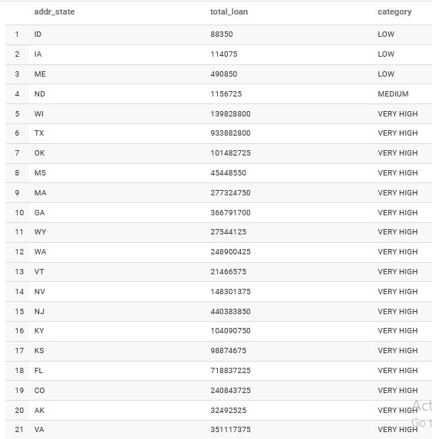

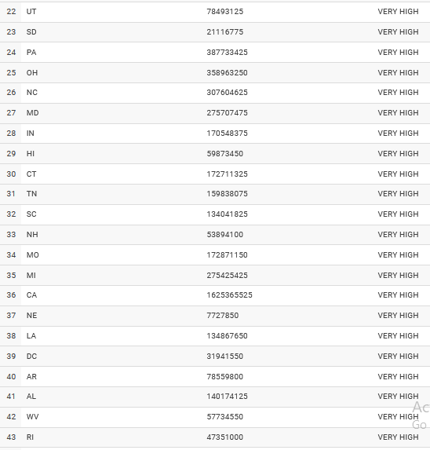

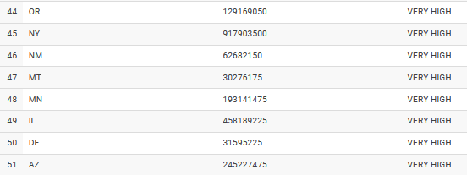

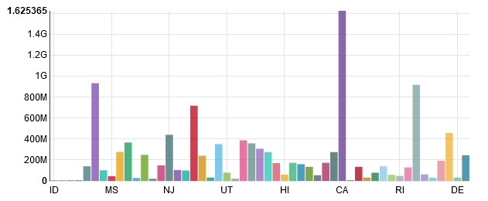

**## Find the last quarter average interest rates by different term loans and overall**

##### create table interest_table1 as SELECT term as t_term,regexp_replace(int_rate,'[^0-9.]','') as intrest_rate from loan_table_1;

##### SELECT avg(intrest_rate)as averageintrestrate_byterm,t_term as term FROM interest_table1 GROUP BY t_term;

##### SELECT avg(intrest_rate)as averageintrestrate_overall FROM interest_table1;

##### 

##### 

##### 

##### ## Find the historical returns by loan grade(Historical performance by grade for all issued loans) and overall

Create table returns_table as select grade as grd_1, sum(loan_amnt) as loan, sum (total_pymnt) as repay

from loan_table_1 group by grade;

Create table history_table as select grd_1 as grade, (loan-repay) as return from returns_table;

Select grade,sum( return) as return_by_grade from history_table group by grade;

Select sum(return) as Overall_return from history_table;

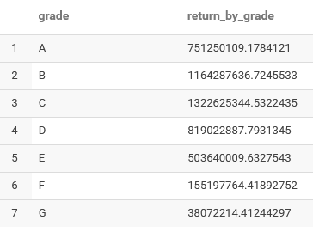

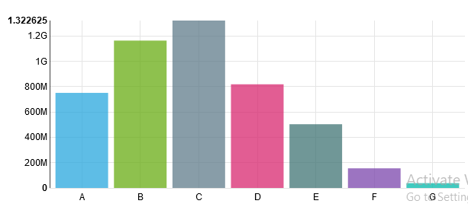

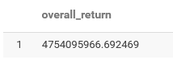

**## Find the historical average interest rates by loan terms and loan grades (also for overall)**

create table avg_intrst as SELECT term as t_term, grade as grd, regexp_replace(int_rate,'[^0-9.]','') as intrest_rate from loan_table_1;

SELECT avg(intrest_rate)as averageintrestrate_byterm_grade , t_term as term, grd as grade FROM avg_intrst GROUP BY t_term, grd;

SELECT avg(intrest_rate)as averageintrestrate_overall from avg_intrst;

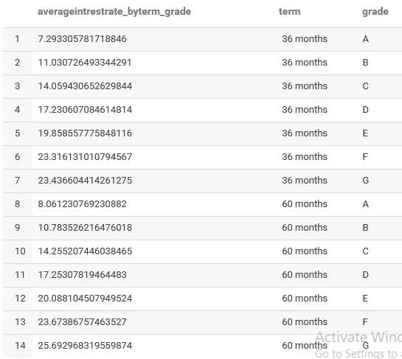

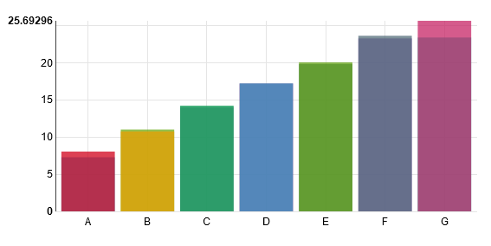

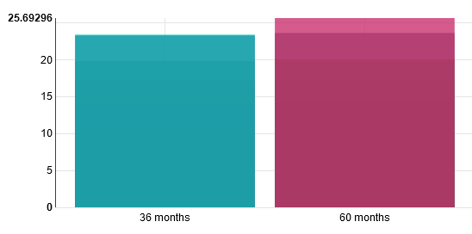

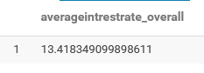

##### ## What is percentage of loans by different loan grades by each year and loan term level (also for overall)

Create table counter as select grade as grade_1, term as t_term, substr(issue_d,5) as Year ,

count(*) as cnt from loan_table_1 group by grade,term, substr(issue_d,5) ;

Create table cntr as select count(*) as ctr from loan_table_1;

Create table loan_final as select counter.grade_1 as grade, counter.t_term as term, counter.Year as yr, counter.cnt as loan ,cntr.ctr as total_loan from counter cross join cntr;

Create table overall_counter as select substr(issue_d,5) as Year , count(*) as cnt from loan_table_1 group by substr(issue_d,5) ;

Create table loan_final_overall as select overall_counter.Year as yr, overall_counter.cnt as loan ,cntr.ctr as total_loan from overall_counter cross join cntr;

Select grade as GRD, term as TRM, yr as YEAR, 100*(loan/total_loan) as Percentage from loan_final;

Select yr as YEAR, 100*(loan/total_loan) as Overall_Percentage from loan_final_overall;

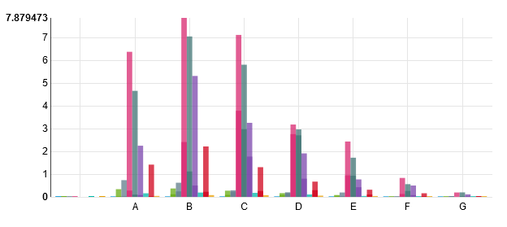

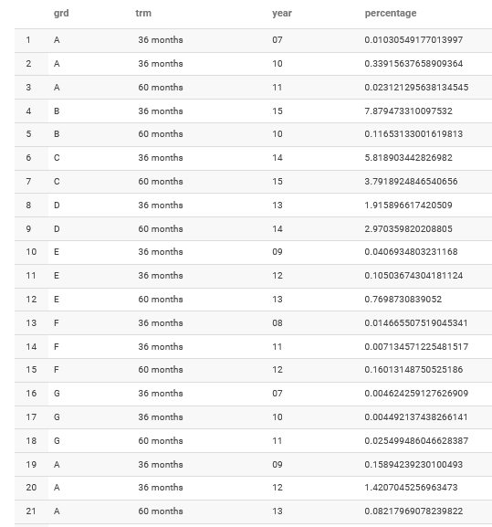

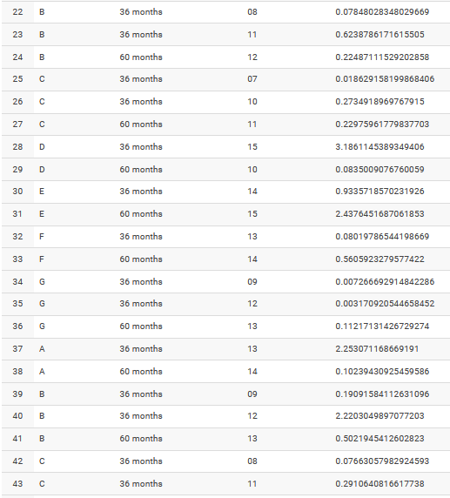

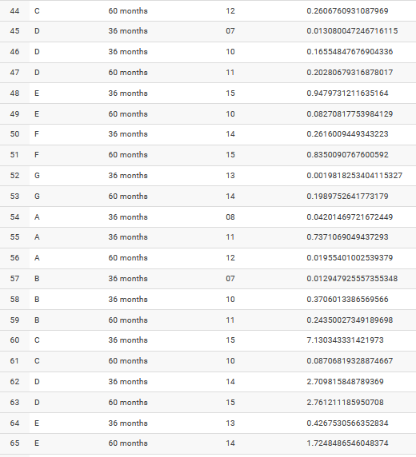

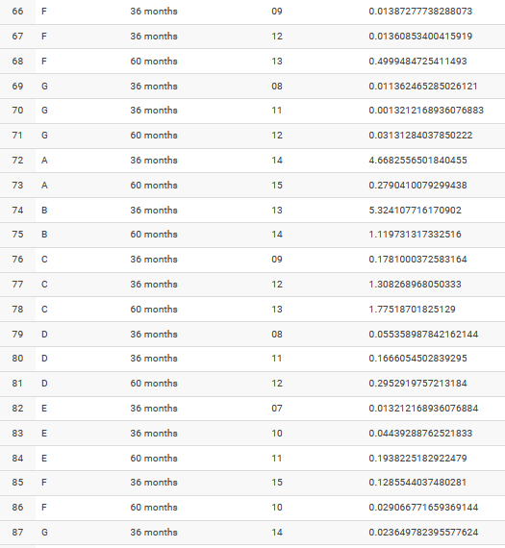

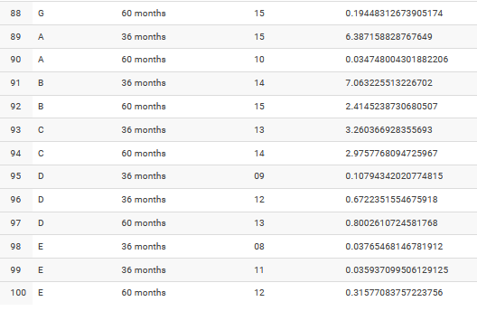

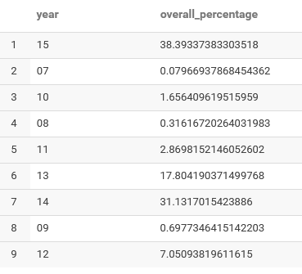

**## What is the loan performance details by different loan grades and overall**

Create table stat as Select loan_status as status, grade as loan_grade, count (*) as countr from loan_table_1 group by loan_status,grade;

Create table ovr_stat as select count(*) as cntr from loan_table_1;

Create table performance as select stat.loan_grade as grade , stat.status as loan_status, stat.countr as per_cnt, ovr_stat.cntr as t_cnt

From stat cross join ovr_stat;

Select grade, loan_status, 100*(per_cnt/t_cnt) as Performace_Percentage from performance;

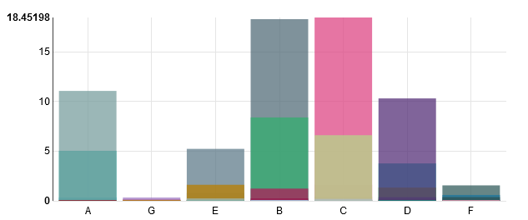

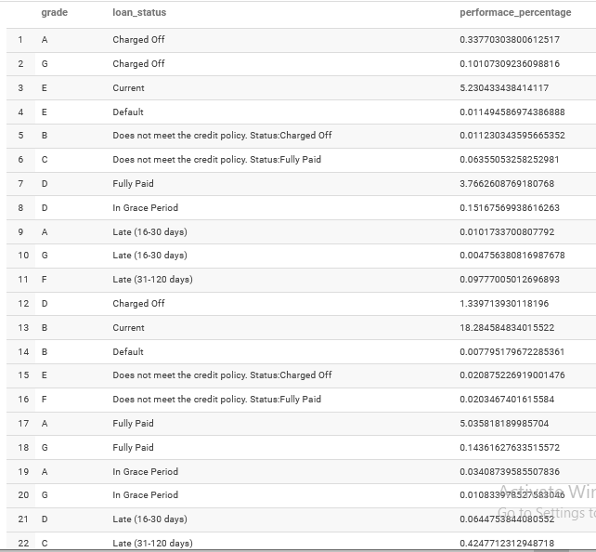

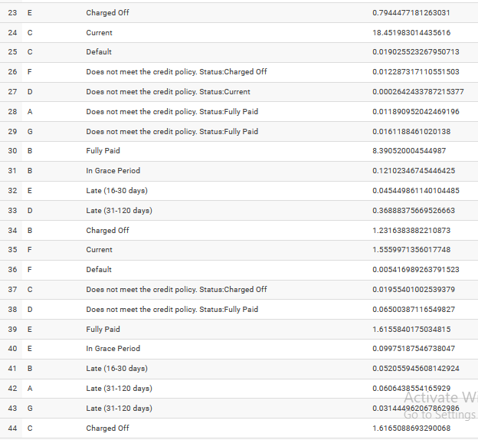

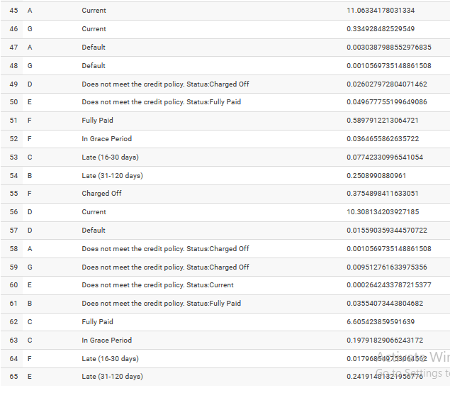

##### ## Find Net Annualized returns by vintage by different loan grades and different loan terms (also for overall

Create table annual as Select cast(regexp_replace(int_rate,'[^0-9.]',' ') as float) as roi, loan_amnt as amnt, grade as grd, term as t_term from loan_table_1;

Create table annual_return as Select grd as grade, t_term as term, (roi*amnt)/100 as rtrn from annual;

Select grade, term, sum(rtrn) as Annualised_Return from annual_return group by grade,term;

Select sum(rtrn) as Overall_Annualised_Return from annual_return;

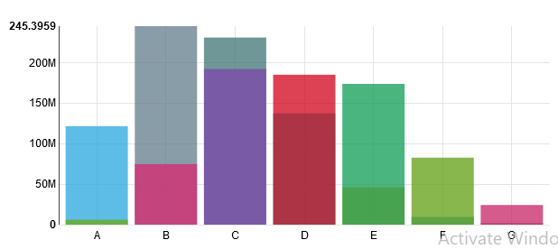

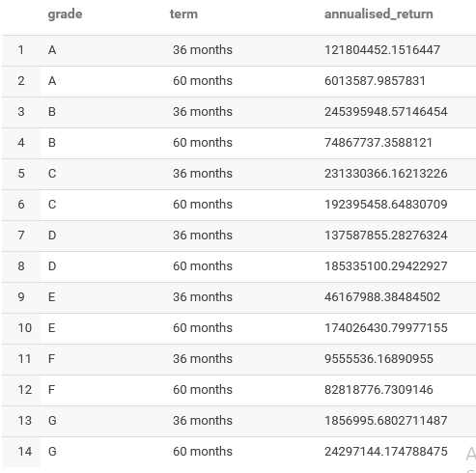

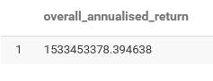

**## What is loan status migration over 9 months Net Chargeoffs:120+days delinquency)**

create table nt as select loan_status as status, count(loan_status) as cnt from loan_table_1

group by loan_status

having loan_status in ( 'In Grace Period', 'Late (16-30 days)', 'Late (31-120 days)', 'Default');

Create table charged_off as Select count(loan_status) as cnt1 from loan_table_1

GROUP BY loan_status

Having loan_status='Charged Off';

Create table migrate_status as select nt.status as status, nt.cnt as count, charged_off.cnt1 as count1 from nt cross join charged_off;

Select status, 100*(count/count1) as Migrtn_Status from migrate_status;

